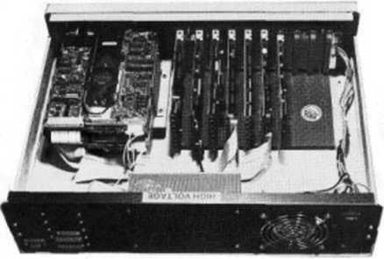

GENIE made in Germany
GENIE lls
The GENIE lls is a computer designed according to the latest technology. High processing speed, excellent high-resolution graphics (option) and great flexibility thanks to the bus-oriented Eurocard system make the GENIE lls a computer with distinctive performance features.
Its operating system - G-DOS - is NewDOS 80 compatible (CP/M as an option). The GENIE lls is thus compatible with the devices GENIE I, II, III, as well as TRS 80, and diskette-compatible with the Colour-GENIE.

